# Front end developer exam

As a user I want to be able to select destination to travel and select most suitable flight for me.

Please follow the requirements:

* The page structure should look as in the following image, Use one of the following (Angular materials, Bootstrap, etc.)

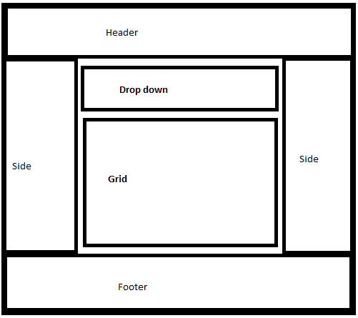

* Drop down\Grid:
  + You need to get the values for the drop down from the following API ‘https://bolt-flight-api.herokuapp.com/api/countriesToFlight’.
  + When the user selects one of the values in the drop down, the app should do GET request to the following API ‘https://bolt-flight-api.herokuapp.com/api/availableFlightByCountry’ in order to get data for the grid.
  + The grid should have the following columns:

|  |  |  |  |  |  |  |
| --- | --- | --- | --- | --- | --- | --- |
| Id | Destination | Departure | Arrive-at | Price | Country | IsSelected |

* + Once the user selects one of the presented flight the app should prefer a POST request to the following a API ‘https://bolt-flight-api.herokuapp.com/api/ToggleSelectedFlight’ with the id of the selected, example of the data:  
    ***[{"id":1,"destination":"paris","arrive_at":"2019-05-12T13:02:45.2614564+03:00","price":"187","isSelected":false,"departure":"2019-05-12T13:02:45.2614564+03:00","country":"france"}]***

## Additional tasks – please select at least two.

* Grid pagination (5 rows per page)
* Replace state list with flags (images located on desktop)
* Grid sorting
* Confirmation popup on selection
* Improve grid styles (hover, click, etc.)